Q1:
.html
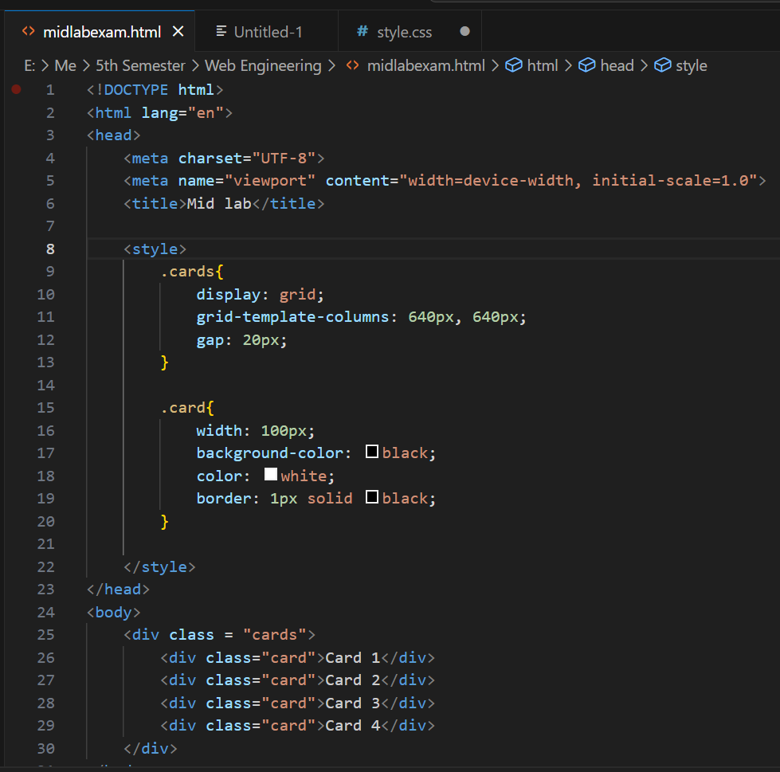

Q2
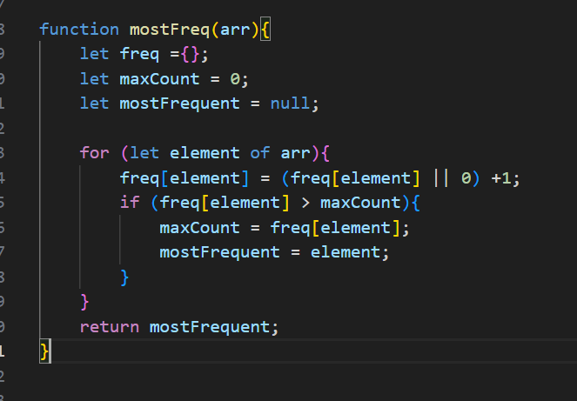

Q3
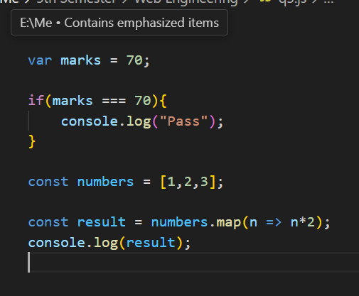

Q4_1
Solution: This function is making sum of sum values
Output: 14
Q4_2
Solution: This function is reversing the string.
Output BEW

Q4_3
Return the largest value.
Output: 19

Q4_4
Removes duplicates
Output: [1,2,3,4]

